Assignment 11.2:

Perform incremental load in Hive

Read from MySQL Table and load it in Hive table.

Create hive table if it does not exist.

If it exists, perform the incremental load.

* Create a table and load table in MySQL

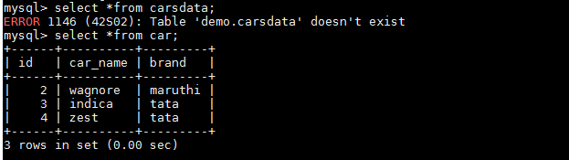

Give sqoop command to import the data from MySQL to hive

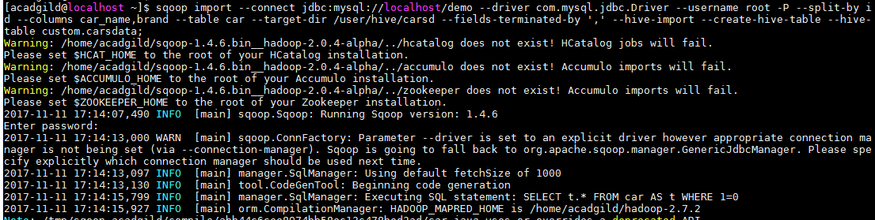

Log in to hive and check the data:

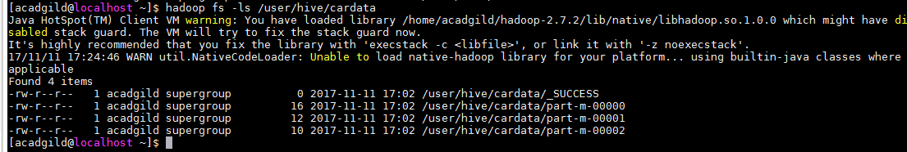

Hive records: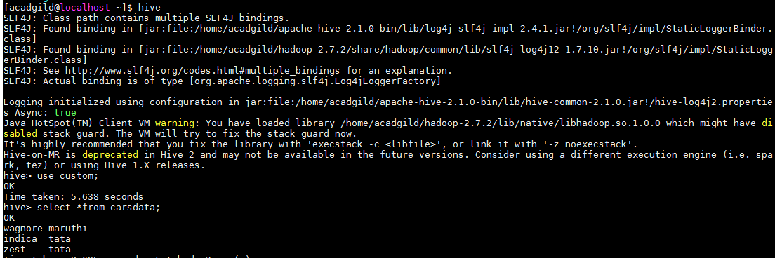

Add few more records in MySQL:

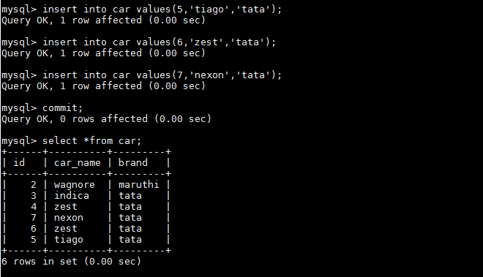

Execute the Sqoop command to transfer the data from mysql to hive again

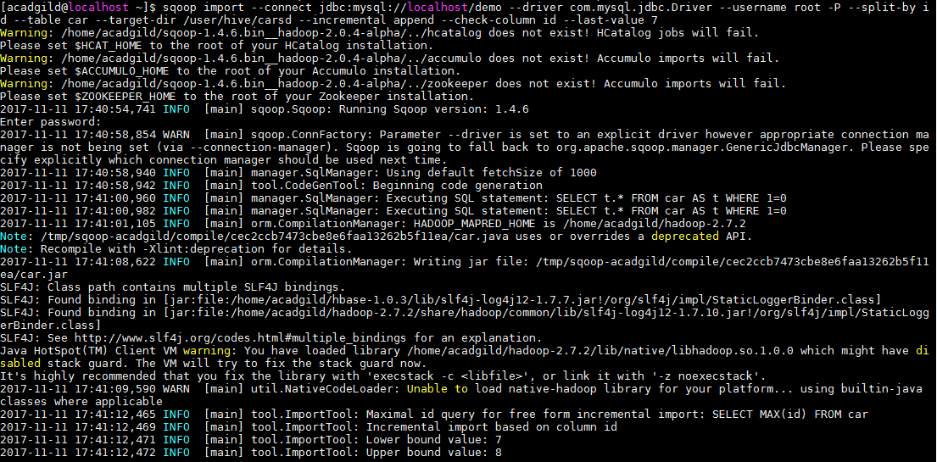

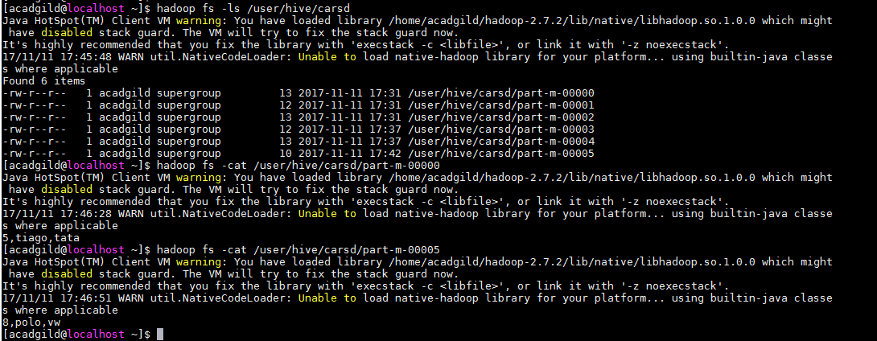

Login into hive to view the appended records.